**Pike and San Isabelle National Forest Travel Management Plan**

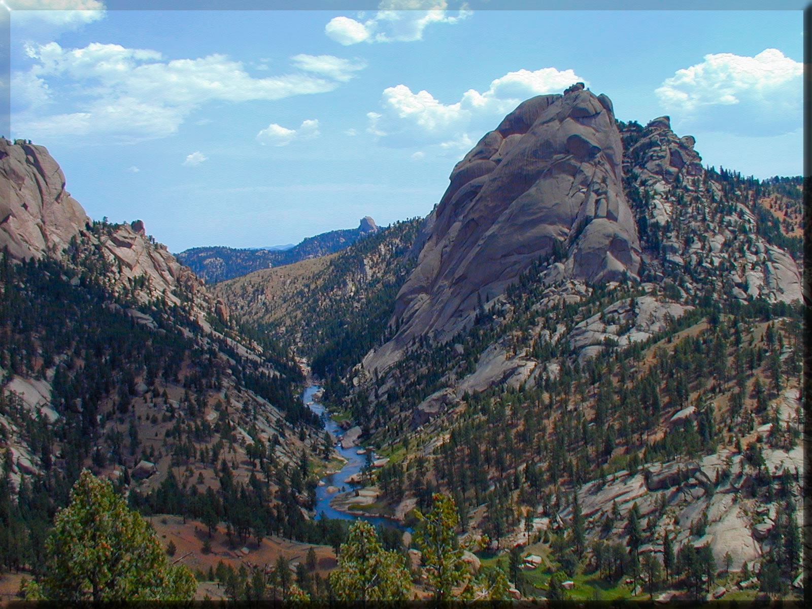

South Platte River flowing through Wildcat Canyon. Photo taken from U.S. Forest Service

**Brief Overview**

The U.S. Forest Service is currently creating a new travel management plan for the Pike San Isabelle National Forest. The most recent management plan was implemented in 1984, and a new plan is needed to address the many changes that have occurred in the areas since. The new plan was set into motion in 2015 after a lawsuit was filed against the National Forest Service for allowing improper motorized vehicle use in the Pike and San Isabelle forests and not following certain NEPA management guidelines. Scoping for the travel management plan started on July 25, 2016 with the release of a [Notice of Intent (NOI)](https://www.gpo.gov/fdsys/pkg/FR-2016-07-25/pdf/2016-17498.pdf) to prepare an environmental impact statement (EIS). The PSI Travel Management plan has its own website- click here for more information.

**Timeline and Updates**

* **November 11, 2015:** Settlement agreement between several non-profits and the U.S. Forest Service. A consequence of the agreement was that the U.S. Forest Service had to produce an EIS and renovated travel management plan for the area
* **July 2016:** Notice of Intent including four alternative management options published.
* **June-September 2016:** Public scoping period opened through September. Over 1200 submittals were received and will be used to guide the EIS.
* **October 2016-present:** The U.S. Forest Service is still drafting a preliminary EIS. A release date has not been set, but it is expected sometime in 2017.

**Providing Comments**

While the scoping period has ended, the PSI will accept and consider comments at any point throughout the NEPA process. There are several ways to provide input, including:

* Provide comments using the Forest Service's Project, Appeals, and Litigation System (PALS) [website](https://cara.ecosystem-management.org/Public/CommentInput?Project=48214)
* Email comments in word of PDF format to: [comments@psitravelmanagement.org](mailto:comments@psitravelmanagement.org)
* Write comments to:

*Travel Management*

*Pike & San Isabel National Forests*

*2840 Kachina Dr. Pueblo, CO 81008*